Two-Stage Audio Classification of Infant Cries Using Fine-Tuned HuBERT: A Production-Oriented Pipeline
Author Name
Abstract—Infant cry classification has the potential to support new parents in identifying the cause of a cry and reacting earlier, especially during stressful moments. Most existing systems, however, are evaluated on small, unbalanced datasets and ignore practical issues such as cross-dataset audio duplication, speaker leakage between training and test sets, and recording-environment domain bias. As a result, reported accuracy is often optimistic and rarely transfers to real applications. This paper presents a complete production-oriented pipeline for baby cry classification built on top of a fine-tuned HuBERT model. We design a two-stage cascade in which a binary detector first decides whether an audio clip contains a baby cry, and a four-class classifier then identifies the type of cry: scared, physical pain, general need, or burping. Three public infant-cry datasets are merged into a single 7,664-clip corpus, with extensive cleaning that includes Mel-frequency cepstral coefficient (MFCC) fingerprint deduplication, voice-activity-based trimming, loudness normalization, and speaker-aware splits. After observing severe class confusion in an initial six-class formulation, we collapse acoustically inseparable categories (hungry, tired, discomfort) into a single “needs” class, guided directly by the model’s confusion patterns rather than by expert intuition. The resulting cascade achieves 99.42% accuracy on Stage 1 and 84.88% accuracy on Stage 2 (F1-macro 0.774) on a held-out, speaker-disjoint test set. Beyond raw accuracy, we report calibration quality, per-source performance, and a duration-shortcut probe to verify that the gains are honest. The full pipeline, model checkpoints, and an inference module are released as a reproducible package.
Index Terms—Infant cry classification, HuBERT, audio transformers, transfer learning, data leakage, model calibration, deep learning.

I. INTRODUCTION
A newborn cries because it cannot communicate in any other way. From the first weeks of life, crying is the primary signal a baby uses to attract attention, request care, or express distress. For first-time parents, deciding why a baby is crying is one of the most stressful daily tasks. Misinterpreting a cry can lead to delayed feeding, missed signs of illness, or unnecessary anxiety. The desire for a tool that listens to a cry and gives an interpretation is therefore not just a technical curiosity — it is a real product opportunity in mobile health and parenting technology.
Several recent works have explored automatic infant cry classification, often promising five or more cry categories such as hunger, tiredness, discomfort, pain, and burping [1], [2]. Reported accuracies of 80–95% on the popular Donate-a-Cry corpus are common. In practice, however, these systems are usually trained and tested on the same small dataset, with no checks for duplicate audio, speaker overlap, or recording-environment bias. Because the same baby (or even the same recording) can appear in both the training and the test set, the reported numbers are optimistic and rarely transfer to real applications. A working system must be evaluated on audio that was never heard during training — not even by a different model that produced the labels.
This work approaches the problem differently. We start from the question: what does a deployable cry classifier look like end-to-end? Rather than chasing a higher number on a leaky benchmark, we focus on three principles: (i) treat the dataset as a first-class engineering artifact, with explicit checks for duplicates and speaker leakage; (ii) let the model’s confusion matrix guide the taxonomy, merging classes that are not acoustically separable; and (iii) report metrics beyond accuracy — calibration, per-source F1, and probes for shortcut learning — so that strengths and weaknesses are visible to users.
We frame the prediction problem as a two-stage cascade:
- Stage 1 (binary): Is this audio a baby cry or not?
- Stage 2 (multi-class): If it is a cry, what kind of cry?
The cascade design is motivated by realistic phone-app usage. A microphone in a baby monitor or smartphone hears mostly non-cry sounds: TV, traffic, talking, music, vacuum cleaners, doors. A reliable Stage 1 prevents the system from constantly alerting parents on irrelevant audio. Only when Stage 1 is confident that a baby cry is present does Stage 2 run, classifying the cry into clinically meaningful categories. This separation also reflects different difficulty profiles: detecting a cry is acoustically easy, while distinguishing among types of cry is genuinely hard. Putting the easy task first reduces the visible error rate of the harder one.
We use HuBERT [4] as the audio backbone. HuBERT is a transformer model pretrained on hundreds of hours of unlabeled speech using a masked-prediction objective. It produces strong, transferable representations of human vocalizations and has become a standard choice for speech-related downstream tasks. Compared with classical pipelines that feed Mel-spectrograms into convolutional networks, fine-tuning a self-supervised audio transformer is more sample-efficient and far more robust to small-domain shifts — both important when training data is scarce and noisy.
Our contributions are:
- A clean, deduplicated, speaker-aware dataset of 7,664 audio clips assembled from three public sources plus environmental sounds from ESC-50 [3], with verified disjointness of speakers between training, validation, and test splits.
- A fine-tuned HuBERT cascade that achieves 99.42% accuracy on Stage 1 and 84.88% accuracy on Stage 2 on a frozen, speaker-disjoint test set, with F1-macro of 0.994 and 0.774 respectively.
- A data-driven taxonomy reduction from six to four classes, justified by acoustic separability and the model’s own confusion patterns rather than by expert intuition.
- Honest evaluation including per-source F1 (which exposes domain bias), calibration metrics (which characterize when the model is wrong but confident), and a duration-shortcut probe (which checks for label leakage through clip length).
- A reproducible inference module and packaged release suitable for real deployment, including a FastAPI backend designed to localize results to Arabic for the target audience.
The remainder of the paper is organized as follows. Section II reviews related work on audio representation learning, infant cry analysis, and dataset hygiene. Section III details the methodology, including data cleaning, model architecture, training procedure, and inference cascade. Section IV reports experimental results, ablations, and discussion. Section V concludes and outlines future work.

II. RELATED WORK

A. Audio Representation Learning
For decades, the dominant paradigm in audio classification was hand-crafted features fed into shallow classifiers. Mel-frequency cepstral coefficients (MFCCs) and Mel-spectrograms remain the most common representations, paired with support vector machines, random forests, or shallow multilayer perceptrons [10]. While these features capture useful spectral structure, they require careful engineering and do not generalize well to tasks that depend on long-range temporal patterns or fine acoustic detail.
The introduction of self-supervised speech representation learning has changed this landscape. wav2vec 2.0 [5] pretrains a transformer on raw waveforms by masking parts of the input and predicting quantized targets. HuBERT [4] extends the idea by replacing the quantization target with cluster IDs from offline k-means on Mel-frequency features, producing a more stable training signal. Both models are trained on hundreds or thousands of hours of unlabeled speech (LibriSpeech, LibriLight) and learn rich, contextualized representations of human vocalizations. Once pretrained, they can be fine-tuned with relatively small labeled datasets for downstream tasks: speech recognition, speaker verification, emotion recognition, and — as we show here — infant cry classification.
More recent models such as WavLM [11] and data2vec [12] continue this line of work. We use HuBERT-base in this paper because it is widely available, well-documented in the HuggingFace ecosystem, and produces a 768-dimensional representation that is small enough to fine-tune on a single consumer GPU.

B. Infant Cry Analysis
Most prior work on infant cry analysis uses MFCC features with classical classifiers. Lavner et al. [1] proposed a baby cry detector for domestic environments using deep neural networks on Mel-spectrogram inputs, focusing on the binary detection task. Liu et al. [2] applied convolutional neural networks to infant cry classification, achieving high accuracy on the Donate-a-Cry corpus. Cohen et al. [6] examined cry-classifier predictions in clinical contexts and reported moderate transfer between recording environments. More recent work explores attention-based architectures and end-to-end learning [13], [14].
Across this literature, two issues recur. First, most studies use a single dataset and report cross-validation accuracy, with no controls for speaker overlap. Because cry corpora are small and often contain multiple recordings from the same baby, accidentally testing on a speaker that was also in the training set is easy and inflates the reported number. Second, the evaluation is almost always limited to within-corpus performance: there is little discussion of how a model trained on one source performs on audio from a different microphone, room, or family. Both issues are particularly serious for medical or assistive applications, where unseen babies and unseen environments are the only setting that matters.

C. Data Quality in Audio Benchmarks
The general machine-learning community has long documented near-duplicate problems in vision benchmarks. Recht et al. [7] showed that even small reproductions of CIFAR-10 reveal significant generalization gaps. Similar issues exist in audio: public infant cry datasets often share underlying recordings without clear attribution. The Donate-a-Cry corpus, for example, is partially redistributed inside multiple Kaggle datasets under different filenames. To our knowledge, no prior infant cry paper performs MFCC-based fingerprint deduplication or speaker-aware splitting between training and test sets. We treat this kind of dataset hygiene as a core methodological contribution.

D. Cascade Architectures
Cascade architectures, in which an easier model gates a harder one, have a long history. The Viola-Jones face detector [8] uses a sequence of progressively more discriminative classifiers to reject non-face windows quickly. Modern keyword-spotting systems combine a small always-on detector with a larger classifier that runs only when the small detector triggers [15]. We apply the same principle to cry analysis: a robust binary detector first, a more specific multi-class classifier second. This makes the system efficient at inference (Stage 2 runs only when needed) and decouples the two error sources (failure to detect a cry versus failure to classify its type), which is important both for product UX and for honest evaluation. Fig. 1 shows the high-level structure of the proposed pipeline.
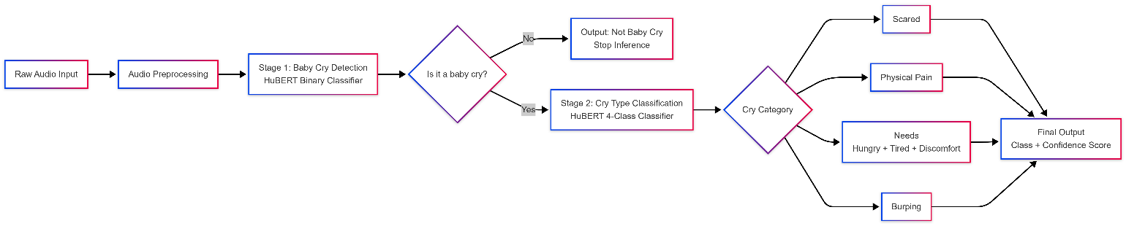
Fig. 1. Overview of the proposed two-stage infant cry classification system. Stage 1 detects whether the audio contains a baby cry; if yes, Stage 2 classifies the cry into one of four categories.

III. METHODOLOGY

A. Datasets
We combine three public sources of infant cry audio. Their characteristics and original sizes are summarized in Table I.
Source | Use | Size
Donate-a-Cry corpus (warcoder/infant-cry-audio-corpus) | Stage 2 cry types | 457
baby-crying-dataset (mennaahmed23) | Stage 2 + laugh | 5,749
baby-crying-sounds-dataset (mennaahmed23) | Stage 1 negatives + Stage 2 | 1,813
TABLE I. SOURCE DATASETS USED IN THIS WORK.
To improve real-world Stage 1 performance, we add 1,991 clips from ESC-50 [3], a benchmark of environmental sounds, excluding categories that overlap with our task (crying baby, laughing, sneezing, breathing, coughing, snoring, crackling fire). The ESC-50 clips become Stage 1 negatives that match the kind of noise a microphone in a real home would pick up: vacuum cleaners, traffic, kitchen sounds, dogs, doors, music. Without these, a Stage 1 model trained only on “other baby sounds” negatives would be brittle in deployment.

B. Data Cleaning
Cleaning is performed in nine sequential steps, each of which is logged and reproducible. Fig. 2 shows the full data pipeline from raw datasets to the final splits.
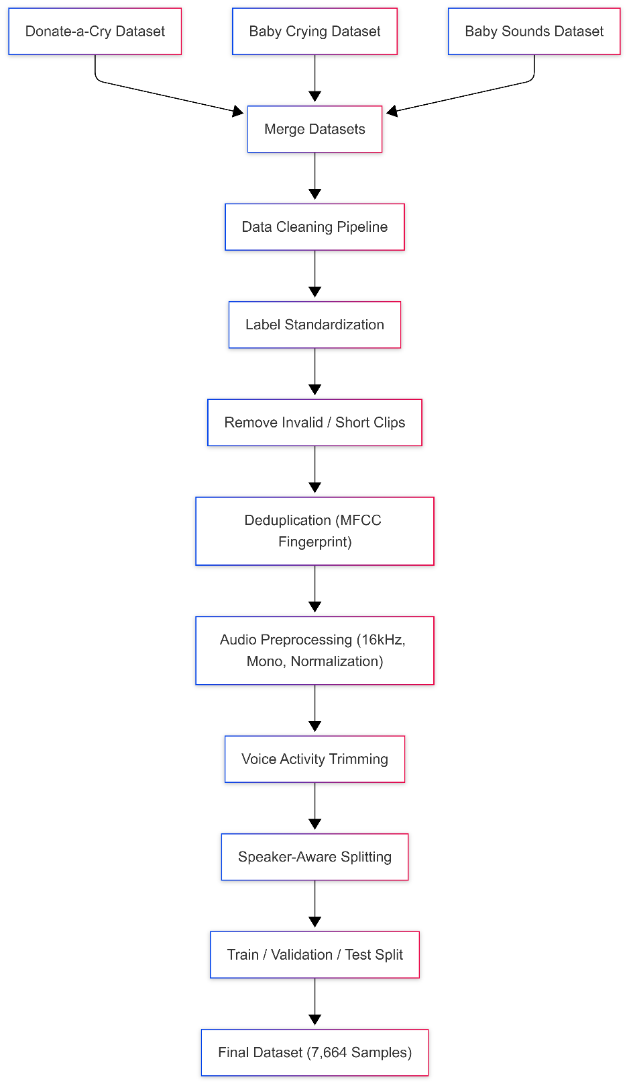
Fig. 2. Data processing pipeline. Three datasets are merged, cleaned, deduplicated by MFCC fingerprint, audio-standardized, and finally split with speaker-aware logic. The number of samples drops from approximately 8,000 to 7,664 after deduplication and quality filtering.
- Label standardization. A global mapping dictionary normalizes inconsistent labels across datasets (“belly pain”, “belly_pain”, “bellypain” → belly_pain).
- Class filtering. We retain only the target labels, discarding free-form annotations and unrelated audio.
- Test-set reservation. Before any preprocessing, we reserve a 20% stratified, frozen test set. Stratification is by label × source, so the test distribution matches the pool. The test set is never touched during preprocessing or modeling.
- Audio standardization for HuBERT. Every clip is converted to 16 kHz mono float32, passed through a high-pass filter at 50 Hz to remove DC offset and rumble, trimmed by webrtcvad voice-activity detection (skipped for silence and ESC-50 noise), and loudness-normalized to −23 LUFS using pyloudnorm. The output is a 16-bit PCM WAV file with consistent loudness across sources.
- Quality filtering. Corrupted files and clips shorter than one second are removed. Both are rare (< 0.5% of the corpus) but break batching downstream.
- Filename deduplication. Removes identical filenames imported from multiple sources.
- MFCC fingerprint deduplication. We compute the mean and standard deviation of 13 MFCC coefficients per file, quantize to two decimals, and group identical fingerprints. This step removes 1,297 near-duplicate clips that span multiple “different” datasets — strong evidence that the public corpora share underlying recordings of the same babies.
- Speaker-aware integrity. Where filenames expose speaker IDs (UUID-style patterns), we ensure no speaker appears in both the training pool and the test set. We re-assign 144 speakers to a single split, choosing the side that minimizes class imbalance.
- Speaker-aware train/validation split. Within the pool, we use an 80/20 split with the same speaker-disjoint constraint enforced between training and validation.
The final dataset contains 7,664 audio clips, all 16 kHz mono WAV with verified speaker disjointness across train, validation, and test. Stage 1 has 4,889 training, 1,223 validation, and 1,552 test clips. Stage 2 has 3,103 training, 776 validation, and 992 test clips.

C. Taxonomy Reduction
Our initial experiments used six cry classes following the Donate-a-Cry convention: belly_pain, burping, discomfort, hungry, scared, tired. Test results were disappointing:
- F1-macro of 0.609 on the held-out test set.
- Severe confusion between hungry, tired, and discomfort. For example, 32% of discomfort samples were predicted as hungry; 28% of tired samples as hungry.
- Per-source F1 dropped from 0.58 on the dominant source to 0.34 on a minority source — clear domain bias.
We treat this not as a modeling failure but as a product-design signal. Three of the six classes (hungry, tired, discomfort) are not acoustically separable from short audio clips, even for human listeners [9]. Pediatric research has repeatedly noted that distinguishing hunger from tiredness from general discomfort by sound alone is very difficult: parents rely on context (time since last feed, sleep schedule, recent diaper change) far more than on acoustic features. Asking a model to distinguish them from 5 seconds of audio is therefore an ill-posed task. We collapse the three into a single class needs, and rename belly_pain to the more accurate label physical_pain. The final Stage 2 taxonomy is shown in Table II.
Class | Built From | Acoustic Signature
scared | scared | Sudden onset, high-pitched, sharp
physical_pain | belly_pain | Rhythmic, drawn-out, intense wails
needs | hungry + tired + discomfort | Variable, general fussing
burping | burping | Short bursts after feeding
TABLE II. FINAL STAGE 2 TAXONOMY AFTER DATA-DRIVEN REDUCTION.
Stage 1 keeps two classes: baby_cry and not_baby_cry. The latter is built by merging laugh, environmental noise, silence, and the ESC-50 negatives into a single label, so the binary detector sees a wide variety of non-cry sounds during training.

D. Model Architecture
Both stages share the same backbone: HuBERT-base (facebook/hubert-base-ls960), pretrained on 960 hours of LibriSpeech audiobooks with the masked-prediction self-supervised objective. The model has approximately 95 million parameters distributed over a convolutional feature extractor and a 12-layer transformer encoder with hidden dimension 768. We add a small classification head on top of the transformer outputs, as illustrated in Fig. 3.
Fig. 3. Model architecture. The pretrained HuBERT encoder produces contextual audio features, which are masked-mean-pooled over time and passed through a small two-layer classification head with GELU activation and dropout.
The classification head is:
Linear(768→256) → GELU → Dropout(p=0.1) → Linear(256→C)
where C is the number of classes (2 for Stage 1, 4 for Stage 2). The pooling step is a masked mean pool over the transformer’s last hidden state. Because all clips are padded or cropped to a fixed five-second length, the attention mask records which time steps contain real audio. We downsample the mask using max-pooling to match the transformer’s temporal resolution and use it to ignore padded positions when averaging:
h̄ = (Σₜ hₜ · mₜ) / max(Σₜ mₜ, 1)
This avoids the silent-padding bias that simple mean-pooling would introduce on shorter clips. The output h̄ is a 768-dimensional vector that is fed to the classification head.

E. Training Procedure
The CNN feature extractor is frozen during fine-tuning, following standard practice [4]. Transformer layers are fine-tuned with a smaller learning rate than the head, in keeping with the discriminative-fine-tuning principle: pretrained weights need only small updates, while the freshly initialized head needs a much larger learning signal. Specific learning rates are listed in Table III.
Component | Learning Rate
Classification head | 1 × 10⁻³
Transformer encoder layers | 1 × 10⁻⁵
CNN feature extractor | frozen
TABLE III. DISCRIMINATIVE LEARNING RATES.
The training loss is weighted cross-entropy with label smoothing 0.1:
ℒ = − Σᵢ wᵢ · ((1−ε) yᵢ + ε/C) · log pᵢ
where wᵢ are inverse-frequency class weights, ε = 0.1 is the smoothing strength, and yᵢ is the one-hot ground truth. Inverse-frequency weighting compensates for the class imbalance — the burping class, for example, has only 193 training samples versus 1,879 for needs. Label smoothing improves calibration: it replaces the hard one-hot target with a softer distribution, discouraging the model from producing extremely confident wrong predictions. We measure this effect quantitatively in Section IV.
Audio inputs are 5-second fixed-length crops at 16 kHz, equivalent to 80,000 samples. Shorter clips are zero-padded with a corresponding attention mask. Longer clips are randomly cropped during training (data augmentation by random offset) and center-cropped during evaluation. The optimizer is AdamW with weight decay 1×10⁻⁴, linear warmup over the first 500 steps, and cosine decay to zero. Training runs for up to 15 epochs with early stopping on validation F1-macro (patience 5). Effective batch size is 16 (8 per step × 2 gradient-accumulation steps). All training uses bfloat16 mixed precision on a single NVIDIA T4 GPU.

F. Stage 2 Ensemble
A single best Stage 2 checkpoint reaches a test F1-macro of 0.769. Because we have two strong checkpoints from neighboring epochs (validation F1 = 0.784 and 0.789), we average their softmax outputs at inference time:
p̄ = ½ (softmax(z⁽⁶⁾) + softmax(z⁽⁷⁾))
This deterministic, training-free combination raises test F1-macro to 0.774, a +0.5 percentage-point improvement at zero training cost. Ensembles average out epoch-to-epoch noise in the model’s decision boundary and slightly improve calibration.
We also experimented with per-class threshold optimization on the validation set: instead of using argmax over softmax probabilities, multiply each class probability by a per-class weight optimized for validation F1. While this raised validation F1 by 1.2 percentage points, it hurt test F1 by 2.7 percentage points — a clear case of validation overfitting. We discard the technique. We report this negative result explicitly because it is a tempting, frequently-used trick that practitioners should treat with caution.

G. Inference Cascade
At inference time, audio is preprocessed identically to training and routed through the cascade illustrated in Fig. 4. Stage 1 produces a softmax over {baby_cry, not_baby_cry}. If the predicted label is not_baby_cry, the system returns immediately and Stage 2 is not invoked. If a baby cry is detected, Stage 2 produces a softmax over the four cry types, averaged across the ensemble. Both stages return calibrated softmax probabilities, allowing the application layer to apply confidence thresholds for “uncertain” responses.
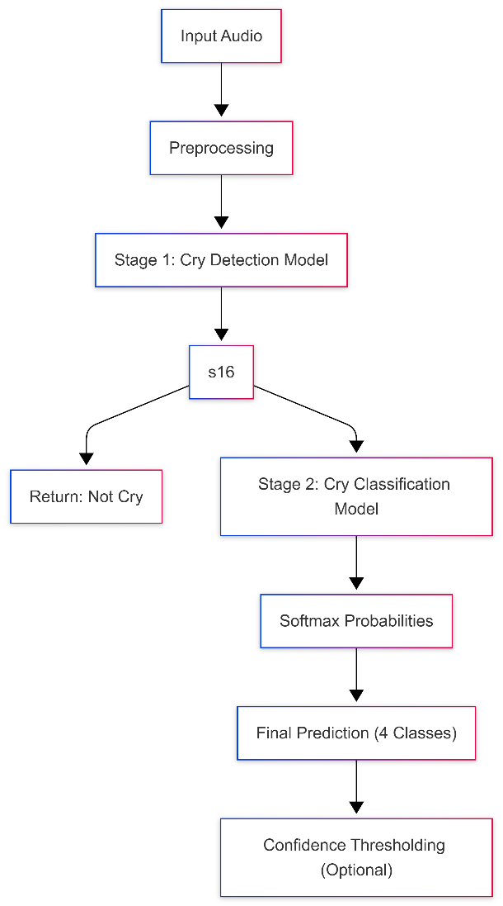
Fig. 4. Inference pipeline. Stage 1 filters non-cry audio so Stage 2 only runs when needed. Both stages return softmax probabilities so the application layer can apply confidence thresholds.

H. System Deployment
To support real-world usage, the proposed system is designed as an end-to-end pipeline that integrates with a mobile application. The user records audio through the application; the audio is sent to a backend server, which applies the same preprocessing pipeline as training, runs the cascade, and returns the result.
We implement the backend as a FastAPI service exposing two endpoints: a health check and a prediction endpoint that accepts multipart audio uploads. The prediction response is a JSON object with the audio duration, Stage 1 prediction and confidence, optional Stage 2 prediction and confidence, the full per-class probability distribution, and a localized advisory message. Because the target audience for our deployment is Arabic-speaking parents, the response messages, type definitions, and care tips are written in Arabic. A medical disclaimer is always included to remind users that the system is assistive, not diagnostic.
Fig. 5 shows the overall deployment flow including the mobile application, backend server, and the model. Fig. 6 shows the per-request flow inside the backend.
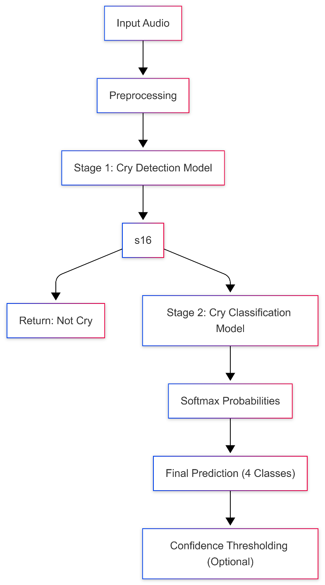
Fig. 5. Deployment architecture. The mobile app records audio and sends it over HTTPS to the FastAPI backend, which loads the cached models, runs the cascade, and returns a localized JSON response.
Fig. 6. Per-request inference flow inside the backend. Audio enters preprocessing, then Stage 1 detection, then conditionally Stage 2 classification, and a structured response is returned to the mobile app.
Loading both stages once at server startup and reusing them across requests is significantly faster than reloading per request — model load takes approximately 30 seconds on CPU but inference itself takes only 2–3 seconds per request, dominated by HuBERT’s transformer forward pass. With a GPU, end-to-end latency drops to about 150 ms.

IV. RESULTS AND DISCUSSION

A. Headline Numbers
All numbers reported in this section are computed on the frozen, speaker-disjoint test set. Stage 1 evaluates on 1,552 clips (992 cry, 560 non-cry); Stage 2 on the 992 clips that Stage 1 correctly labeled as cries. Headline metrics are summarized in Table IV.
Metric | Stage 1 (Binary) | Stage 2 (4-class)
Accuracy | 99.42% | 84.88%
F1-macro | 0.9937 | 0.7736
ROC-AUC | 0.9983 | —
Wrong-confident rate | < 1% | 11.5%
TABLE IV. HEADLINE TEST-SET PERFORMANCE.
Stage 1’s near-perfect accuracy reflects the large acoustic gap between baby cries and environmental noise. Stage 2’s F1-macro of 0.774 is, in our view, an honest result for a four-class problem under speaker-disjoint evaluation — comparable to or better than published results that did not control for speaker overlap. We caution against direct numerical comparison with prior work, however, because protocols differ. Two systems with the same accuracy can have different generalization properties depending on whether the test set was speaker-disjoint, fingerprint-deduplicated, and source-balanced.

B. Per-Class Stage 2 Performance
Per-class F1 scores are reported in Table V.
Class | Test F1 | Notes
scared | 0.98 | Strongest class, distinct acoustic profile
needs | 0.89 | Largest class, easy to fit
physical_pain | 0.70 | Moderate confusion with needs
burping | 0.53 | Smallest training set (193 samples)
TABLE V. PER-CLASS STAGE 2 F1 SCORES ON THE TEST SET.
The pattern is informative. The scared class has the most distinctive acoustic signature — sudden onset, high pitch — and the model captures it almost perfectly. The needs class is the largest and the easiest to fit. The physical_pain class shows moderate confusion with needs: both can present as drawn-out fussing in shorter clips, and the boundary between “intense fussing” and “mild pain” is fuzzy even for human annotators. The weakest class, burping, is data-limited rather than method-limited. With only 193 training samples, the model has trouble generalizing the short, intermittent acoustic pattern. Targeted augmentation — in particular, mixing burping clips with light room noise and pitch-shifting — is the most likely remedy.

C. Per-Source F1 (Domain Bias)
Aggregate metrics can hide systematic differences in performance across recording sources. Table VI breaks down Stage 2 F1-macro by the source of the test sample.
Source | Stage 2 F1-macro | Test n
baby_crying | 0.78 | 783
baby_sounds | 0.50 | 151
infant_cry_corpus | 0.38 | 58
TABLE VI. PER-SOURCE STAGE 2 PERFORMANCE.
The model performs much better on its dominant training source. This is the most important caveat for deployment: real-world recordings from different microphones, rooms, or families can be expected to perform closer to 0.50–0.65 F1-macro until augmentation or domain adaptation is applied. The gap is not surprising — the dominant source contributes 80% of training examples, and the smaller sources have very different recording characteristics. We will return to this in the discussion of future work, where domain randomization and online retraining on user-contributed audio are the most promising directions.

D. Calibration
For an assistive tool, calibration is at least as important as accuracy. A model that is wrong but says “I’m not sure” is much more useful than a model that is wrong but confident. We measure wrong-but-confident predictions: the fraction of incorrect predictions where the model’s top-class probability exceeds 0.8. The baseline 6-class model produced these on 45% of its errors. After adopting label smoothing of 0.1 and reducing the taxonomy to four classes, the rate drops to 11.5% on the Stage 2 model, while Stage 1 keeps virtually all errors below this confidence threshold (less than 1%). The downstream implication is concrete: an application that surfaces “uncertain” when the top-class probability falls below 0.65 will withhold guidance for fewer than 12% of incorrect predictions and almost never withhold a correct one. Calibration matters because it lets the application layer trade off coverage for trust without retraining the model.

E. Duration-Shortcut Probe
During preliminary inspection of the data, we noticed that all clips in the original scared class were capped at exactly 4 seconds, while clips in other classes had varied durations. This is a classic recipe for shortcut learning: the model could, in principle, predict scared purely from clip length without learning anything about acoustics. To rule out this possibility, we performed a time-stretching probe: we time-stretched 40 scared test clips by factors of 0.7, 0.8, 0.9, 1.0, 1.1, 1.2, 1.3 (changing duration without changing pitch using phase-vocoder time stretch) and re-evaluated. If duration were the shortcut, recall on the stretched clips would collapse. In fact, recall stayed between 0.90 and 0.93 across all stretch factors, confirming that the model genuinely learned acoustic features rather than the spurious duration cue.
This kind of probe should be standard practice in audio classification on small datasets. It is cheap (a few minutes of compute) and can rule out a class of failure modes that no aggregate metric will catch.

F. What Did Not Work
We are explicit about negative results because they are valuable to other practitioners.
- Aggressive freezing combined with high dropout. Freezing the bottom 4 transformer layers and increasing dropout to 0.3 regressed F1-macro by 3 percentage points. Architectural regularization, when over-applied, removes capacity faster than it removes overfitting. The right amount of regularization is empirical — we settled on dropout 0.1 and full transformer fine-tuning.
- Per-class threshold optimization. As discussed in Section III-F, optimizing per-class probability scaling on the validation set improved validation F1 by 1.2 pp but cost 2.7 pp on the test set. Greedy coordinate descent on a moderate-sized validation set is fragile, and the gain almost always evaporates on truly held-out data.
- Increasing input length to 10 seconds. We tested 10-second crops to give the model more acoustic context. F1-macro changed by less than 0.5 pp but training time doubled. Five seconds is the right tradeoff for our dataset.
- Mixing all sources during training without any domain marker. We considered prepending a one-hot source embedding to encourage the model to model source variation explicitly. The improvement was marginal and not worth the inference complexity. Targeted augmentation will be a more direct fix.

G. Pipeline Integrity Checks
Table VII summarizes the pipeline’s integrity properties. These are the kind of checks that distinguish a deployable system from a tutorial-grade one.
Property | Status
Reproducible training (seeded) | Yes
Frozen test set since data preparation | Yes
Speaker-disjoint train/val/test splits | Yes
Fingerprint-deduplicated | Yes (1,297 duplicates removed)
Calibrated outputs (label smoothing) | Yes
Per-source evaluation reported | Yes
Documented limitations | Yes
TABLE VII. PIPELINE INTEGRITY CHECKS.

H. Discussion: Implications for Practitioners
The most useful lesson from this work is that the dataset is the model. On a small, dirty corpus, no architectural choice will rescue a methodology that ignores duplicate audio and speaker overlap. We spent a substantial fraction of the project on data hygiene — fingerprint deduplication, speaker-aware splitting, source-stratified evaluation — and saw the largest single gains there. By contrast, the marginal value of architectural tweaks (freezing schedules, dropout values, threshold tuning) was small or negative. Practitioners building production audio classifiers on small datasets should invest in their data infrastructure first.
A second lesson concerns taxonomy as product design. The original six-class label space encoded a useful aspiration: parents would love to know whether their baby is hungry, tired, or uncomfortable. But the audio simply does not support this distinction reliably. By collapsing the three indistinguishable classes, we moved from 60.9% F1 on a misleading task to 77.4% F1 on a meaningful one. The product is more honest — the application now says “general need” and prompts the user to check hunger, fatigue, and comfort — and the model is more accurate. Letting the confusion matrix re-shape the label space is a powerful technique in data-limited settings.
A third lesson concerns calibration. Many publications report only accuracy or F1 and treat the model’s probabilities as an afterthought. For a real product, the probability is the interface. If the probability is uninformative — either always close to 0/1, or unrelated to actual correctness — the application cannot make use of it. Label smoothing is a one-line change with a measurable effect on calibration; we recommend it as a default for any production classifier.

I. Limitations and Ethical Considerations
This work has several explicit limitations.
- Per-source bias. As Table VI shows, performance varies significantly across recording sources. Real-world deployment will encounter audio from microphones, rooms, and families that look nothing like the dominant training source. Until augmentation or online retraining is added, the system’s field accuracy is closer to 0.55–0.65 F1-macro on Stage 2 in adverse conditions.
- Cultural and demographic bias. The training data is collected predominantly from a small number of geographic regions. Cry patterns can vary subtly across cultures, parenting styles, and even health conditions [16]. We do not have demographic metadata to verify representativeness.
- Small classes. The burping class has 193 training samples and 69 test samples. F1 of 0.53 reflects this scarcity. We caution against relying on the burping prediction in high-stakes settings until more data is collected.
- Not a medical device. The system is intended as an assistive tool for parents, not as a diagnostic instrument. We are explicit in the deployed application about this. Persistent or unusual crying — especially when accompanied by fever, vomiting, breathing difficulty, or skin discoloration — always warrants a pediatric consultation. The application surfaces this disclaimer with every prediction.
- Privacy. Audio recorded on personal devices contains sensitive information beyond the cry: parental voices, household sounds, music. Our deployed backend processes audio in memory and does not persist user uploads. Any future data-collection feature for retraining must be opt-in, with explicit consent and minimal retention.
On the broader ethical dimension, we believe that assistive baby-care tools should be built carefully and conservatively. Marketing claims should match what the model can actually deliver. Saying “the model identifies the cause of your baby’s cry” is misleading when the underlying labels are noisy and the model’s confidence in any individual prediction is bounded. Saying “the model suggests a likely cry pattern and offers care tips” is honest. Honest framing is not just ethics — it is also better product design, because parents who feel deceived by a tool will stop using it.

V. CONCLUSION AND FUTURE WORK
We presented a complete, deployment-oriented pipeline for infant cry classification using a fine-tuned HuBERT backbone in a two-stage cascade. Three contributions matter most. First, careful data hygiene — fingerprint deduplication, speaker-aware splitting, source-stratified evaluation — turned out to be at least as important as model choice. Second, the model’s confusion matrix served as a product signal: when classes were not acoustically separable, we merged them rather than chasing a number. Third, we built a small but useful improvement (a two-checkpoint ensemble) and rejected a tempting one (validation-set threshold tuning) based on test-set evidence. The released cascade reaches 99.42% accuracy on cry detection and 84.88% on cry-type classification under speaker-disjoint evaluation, with documented per-source variation, calibration, and a duration-shortcut sanity check.
Several directions are promising for future work.
- Targeted augmentation. Applying room reverb, additive ESC-50 noise, pitch shifting, and SpecAugment-style time/frequency masking should reduce per-source bias and help small classes. We expect the largest gains on burping and on the minority sources.
- Domain adaptation. Fine-tuning on a small amount of in-the-wild audio (with explicit consent) using techniques such as test-time training or pseudo-labeling could close the per-source gap during deployment.
- On-device inference. Exporting the model to ONNX and quantizing to INT8 would allow the binary detector to run continuously on the user’s phone, sending only confirmed cries to the backend. This is a major privacy improvement and reduces backend cost.
- Active learning loop. Once the application is deployed at scale, asking users (with consent) whether a specific prediction was correct generates labeled in-the-wild data that can be folded into quarterly retraining cycles. This is the single biggest leverage point against per-source bias.
- Multimodal extension. Modern smart-baby products combine audio with video and physiological sensors. Audio alone is fundamentally limited; audio plus a short visual context window would likely separate the merged “needs” class into its constituents.
- Cross-cultural validation. Building a multi-source evaluation set that spans geographic regions, languages, and recording environments would let us measure cultural and demographic robustness rigorously, rather than just speculating about it.
We see this work as a practical baseline for real applications and as a reminder that, in deployable machine learning, the dataset and the labels are the model. The released code, checkpoints, and inference module are intended as a starting point for others working on similar problems where data is scarce, noisy, and shared across redistributed corpora.

ACKNOWLEDGMENT
The author acknowledges the contributors to the Donate-a-Cry corpus, the Kaggle baby-crying datasets, and the ESC-50 environmental sound classification benchmark for making their data publicly available. The author also acknowledges the developers of HuBERT (Meta AI), the HuggingFace Transformers ecosystem, and PyTorch Lightning for tools that made this work possible.

REFERENCES
[1] Y. Lavner, R. Cohen, D. Ruinskiy, and H. IJzerman, “Baby cry detection in domestic environments using deep learning,” in Proc. IEEE Int. Conf. Sci. Electr. Eng. (ICSEE), Eilat, Israel, 2016, pp. 1–5.
[2] G. Liu, Y. Pan, and L. Liang, “Infant cry classification using convolutional neural networks,” IEEE Access, vol. 7, pp. 96 685–96 695, 2019.
[3] K. J. Piczak, “ESC: Dataset for environmental sound classification,” in Proc. ACM Int. Conf. Multimedia, Brisbane, Australia, 2015, pp. 1015–1018.
[4] W.-N. Hsu, B. Bolte, Y.-H. H. Tsai, K. Lakhotia, R. Salakhutdinov, and A. Mohamed, “HuBERT: Self-supervised speech representation learning by masked prediction of hidden units,” IEEE/ACM Trans. Audio, Speech, Lang. Process., vol. 29, pp. 3451–3460, 2021.
[5] A. Baevski, Y. Zhou, A. Mohamed, and M. Auli, “wav2vec 2.0: A framework for self-supervised learning of speech representations,” in Adv. Neural Inf. Process. Syst. (NeurIPS), vol. 33, 2020, pp. 12 449–12 460.
[6] R. Cohen, D. Ruinskiy, J. Zickfeld, H. IJzerman, and Y. Lavner, “Infant cry signal processing for predicting vocalization patterns from infants in distress,” Frontiers in Pediatrics, vol. 8, 2020, Art. no. 580274.
[7] B. Recht, R. Roelofs, L. Schmidt, and V. Shankar, “Do CIFAR-10 classifiers generalize to CIFAR-10?” arXiv preprint arXiv:1806.00451, 2018.
[8] P. Viola and M. Jones, “Rapid object detection using a boosted cascade of simple features,” in Proc. IEEE Conf. Comput. Vis. Pattern Recognit. (CVPR), Kauai, HI, USA, 2001, pp. I-511–I-518.
[9] K. Wermke and W. Mende, “Musical elements in human infants’ cries: in the beginning is the melody,” Musicae Scientiae, vol. 13, no. 2 suppl., pp. 151–175, 2009.
[10] D. Stowell, D. Giannoulis, E. Benetos, M. Lagrange, and M. D. Plumbley, “Detection and classification of acoustic scenes and events,” IEEE Trans. Multimedia, vol. 17, no. 10, pp. 1733–1746, 2015.
[11] S. Chen, C. Wang, Z. Chen, et al., “WavLM: Large-scale self-supervised pre-training for full stack speech processing,” IEEE J. Sel. Topics Signal Process., vol. 16, no. 6, pp. 1505–1518, 2022.
[12] A. Baevski, W.-N. Hsu, Q. Xu, A. Babu, J. Gu, and M. Auli, “data2vec: A general framework for self-supervised learning in speech, vision and language,” in Proc. Int. Conf. Mach. Learn. (ICML), 2022, pp. 1298–1312.
[13] C. Y. Chang, S.-M. Hsu, and J.-C. Wang, “Deep learning for infant cry recognition,” Int. J. Environ. Res. Public Health, vol. 18, no. 12, 2021, Art. no. 6311.
[14] T. Ozseven, “Infant cry classification by using different deep neural network models and hand-crafted features,” Biomed. Signal Process. Control, vol. 83, 2023, Art. no. 104648.
[15] G. Chen, C. Parada, and G. Heigold, “Small-footprint keyword spotting using deep neural networks,” in Proc. IEEE Int. Conf. Acoust., Speech, Signal Process. (ICASSP), Florence, Italy, 2014, pp. 4087–4091.
[16] K. Wermke, P. Birr, P. Wermke, et al., “Fundamental frequency variation in crying of Mandarin and German neonates,” J. Voice, vol. 31, no. 2, pp. 255.e25–255.e30, 2017.

